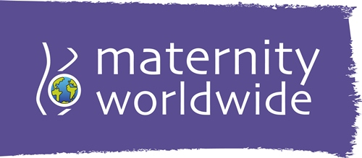
Registered Charity No: 1111504
Christmas Card Order Form
Community Base
113 Queens Road
Brighton
BN1 3XG
www.maternityworldwide.org
01273 234033
info@maternityworldwide.org

Please complete this form and return it together with payment to the above address.
Your details:
Name:
Address:
Email:
Delivery details:
Name:
Address:
Order details (please enter quantity required):
Mother and Baby Christmas Card (£4.50 for 10 cards):
Snow in Preston Park Christmas Card (£4.50 for 10 cards):
Nativity Christmas Card (£4.50 for 10 cards):
Post and Packing: Please add £1 for one or two packs, £2 for three or four packs and £3 for five or six packs.
Payment method and total amount:
☐ Cheque ☐ Cash ☐ Credit / Debit card over the phone
☐ Online via JustGiving, reference number of payment:
☐ Online via PayPal, reference number of payment:
Date of payment: Amount:
Signed: Date:

To receive our quarterly eNewsletter packed with info about our projects and events please tick here: ☐ Your details will not be passed on to anyone and you can unsubscribe at any time.


If you are a UK taxpayer and you like us to reclaim 25p for every £1 you have donated now and on future donations at no extra cost to you please tick here: ☐ Please note to qualify for GiftAid what you have paid in Income Tax and/or
Capital Gains Tax must at least equal the amount we claim in a tax year.

Thank you for your support!

